
Achieved
Advanced to*
Administered
Analyzed
Arranged
Assisted
Built
Clarified
Conceived
Constructed
Consulted
Controlled
Converted
Coordinated
Correlated
Created
Delegated
Demonstrated
Designed
Detailed
Developed
Devised
Directed
Discovered
Doubled
Earned
Effected
Engineered
Established
Evaluated
Executed

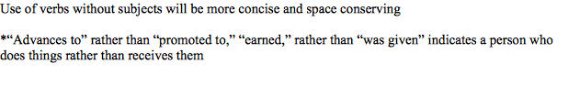
Expanded
Experienced
Financed
Formed
Formulated
Founded
Generated
Graduated
Halved
Headed
Improved
Implemented
Increased
Innovated
Initiated
Inspired
Installed
Integrated
Interviewed
Invented
Justified
Keynote
Led
Licensed
Managed
Maintained
Mastered
Mediated
Motivated
Negotiated
Nominated

Operated
Ordered
Originated
Organized
Overcame
Participated
Performed
Pioneered
Planned
Prepared
Promoted
Provided
Reconciled
Researched
Reduced
Reorganized
Reported
Served
Simplified
Sparked
Solved
Succeeded
Supervised
Transformed
Trebled
Unified
Verified
Won
Wrote
Wrought

